MINI CATTLEYA HYBRIDS
- What miniature Cattleya species is in the background of most orange to red mini-catt hybrids? LIst the number and type of awards for this species.

- List 3 key miniature Cattleya species, with the type and number of awards to date

- This plant comes to your table labeled as C. coccinea. Would you award this plant? Flowers have a natural spread of 9.0cm. Why or why not?

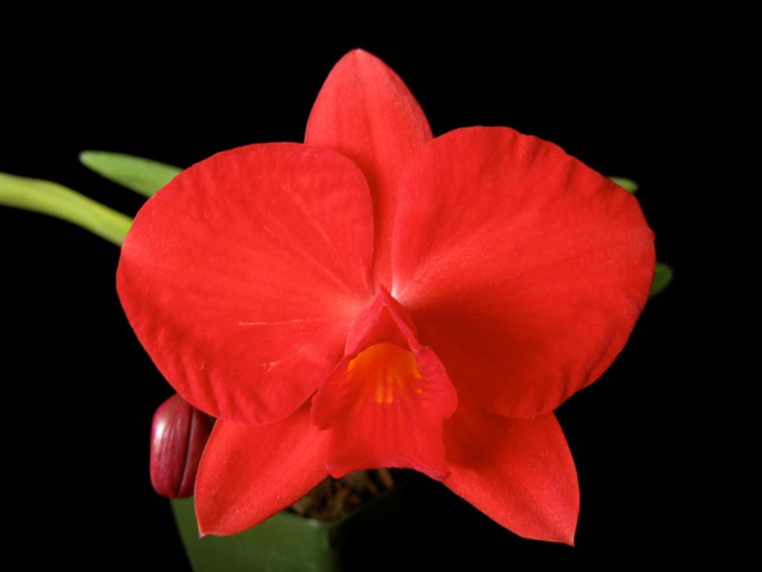
- How many flowers would you expect on a single inflorescence for today’s mini-catt hybrids. Are there any hybrids where 1 flower might be acceptable in judging?

- Name this cattleya species. How many flowers can it have on a single inflorescence? How many flowers would you expect in its direct hybrids? What is the largest nat. spread width in the awards?

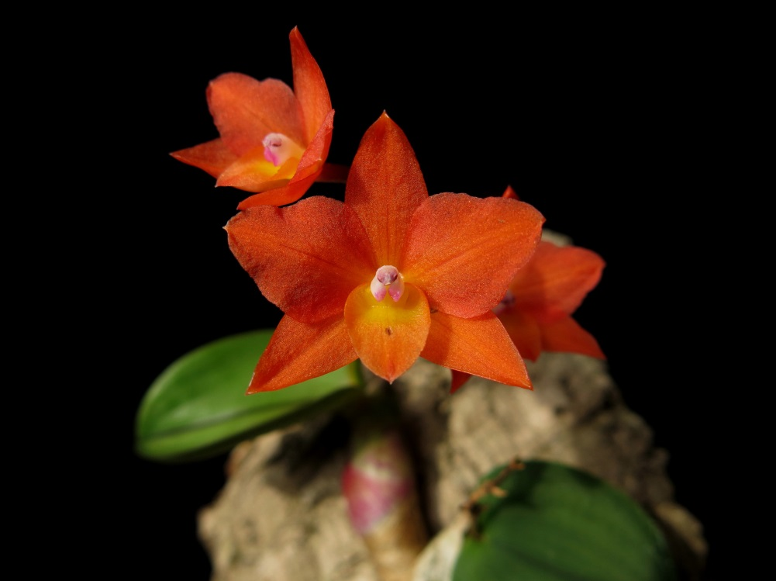

- There are now mini-catt spotted hybrids. What are the species responsible for reducing plant size for the spotted hybrids?

- Please provide an award description of the below mini-catt (assume certain characteristics such as substance and texture):
